1.An overview of the intended application and WHY you feel it’s valuable.

2.A set of DETAILED screen-by-screen design layouts with annotations describing all UI/UX components and all data relevant to the screen.

3.A breakdown of roles by group member.

4.A schedule for completion of various tasks.

5.A screenshot of your Jira, Trello, or Project Management Board that shows breakdown of tasks – assigned to group members with a schedule.

Possible application names:

* Mambo in Motion

1. Mambo in Motion is a Node.js-based application utilizing React, database management, parrot-drone node packages, and user authentication. The application of drones in today’s society offers a myriad of opportunities. Our application will focus on using the drones in an entertaining and educational manner. Mambo in motion aims to utilize both the autonomous functions as well as the real-time, user-controlled functions of its SDK.

2. Real-time user-controlled UI will resemble this:

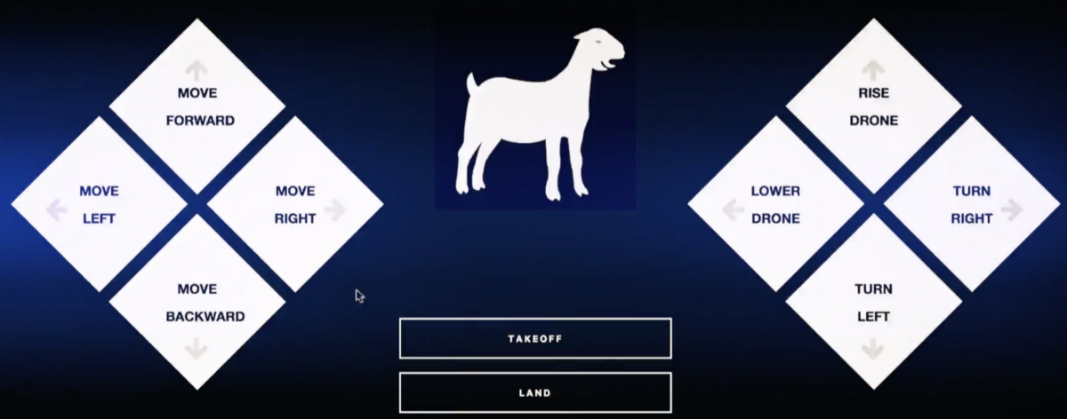

It will have buttons for each basic drone function (e.g. move forward, rise).

Our autonomous-functionality will utilize a similar template, but with text input fields. Distances will be entered in meters, and time in seconds.

3. Andrew B. - Manage the flow and deadlines for project. Incorporate API routes, HTML routes, node packages for drones, and drone functionality.

Charles D. - Incorporate API routes, HTML routes, node packages for drones, and drone functionality.

Asif K. - user authentication utilizing passport JS, Oauth, JSON Web Tokens, or other JS library for dealing with NoSQL or MySQL database management

Sirish K. - user authentication utilizing passport JS, Oauth, or other JS library for dealing with NoSQL or MySQL database management, powerpoint presentation

Ivan V. - front-end UI design, powerpoint presentation

4.

|  |  |
| --- | --- |
| **Deadline** | **Task** |
| Monday, May 14th | Submit Plan of Action |
| Friday, May 18th | Mini-presentation, have some basic functionality complete for using drone |
| Wednesday, May 23th | Deploy by end of the day |
| Thursday, May 24th | Work on and polish presentation, demo application with drone |

5.

|  |  |
| --- | --- |
| **Andrew B.** | 5/18: Finish API and HTML routes; choose node packages for drone and pseudocode how to utilize them  5/21: Have majority of drone functionality complete on the back-end  5/23: Ensure UI and back-end communicate seamlessly |
| **Charles D.** | 5/18: Finish API and HTML routes; choose node packages for drone and pseudocode how to utilize them  5/21: Have majority of drone functionality complete on the back-end  5/23: Ensure UI and back-end communicate seamlessly |
| **Asif K.** | 5/16: Decide which user authentication package and database management system to use  5/22: Successfully integrate user auth. and db into app |
| **Sirish K.** | 5/16: Decide which user authentication package and database management system to use  5/22: Successfully integrate user auth. and db into app |
| **Ivan V.** | 5/18: Finish a static version of our UI  5/23: Work with back-end team to make sure UI and server-side logic are integrated successfully |

**Project Resources:**

* [**https://medium.com/code-school/flying-a-drone-using-javascript-28e7bce888ec**](https://medium.com/code-school/flying-a-drone-using-javascript-28e7bce888ec)
* [**https://www.npmjs.com/package/ar-drone**](https://www.npmjs.com/package/ar-drone)
* [**https://www.npmjs.com/package/ardrone-autonomy**](https://www.npmjs.com/package/ardrone-autonomy)
* [**https://www.npmjs.com/package/node-server-ar-drone**](https://www.npmjs.com/package/node-server-ar-drone)
* [**https://www.npmjs.com/package/parrot-minidrone**](https://www.npmjs.com/package/parrot-minidrone)
* [**https://www.npmjs.com/package/ardrone-webflight**](https://www.npmjs.com/package/ardrone-webflight)
* [**https://jwt.io/introduction/**](https://jwt.io/introduction/)
* [**https://auth0.com/**](https://auth0.com/)
* [**http://www.passportjs.org/**](http://www.passportjs.org/)